***Southwest***

***Software***

***Development***

***Team***

**The design of this is fine**

**Second Year Computing Project**

**2011/2012**

**Fully Automated Payroll System**

**Design & Development Team:**

**James Madden: X00086390:**

**Project Manager, Customer Liaison, Software and Database Development, System Testing & Quality Control.**

**Shane Murphy: X00085315:**

**System Design, Software and Database Development, System Testing & Quality Control.**

**Maciej Macierzynski: X00086366:**

**System Design, Software and Database Development, System Testing & Quality Control.**

**2nd deliverables due (User Manual Design) 27/2/2012 - Completed**

Contents

Installation 3

Company Setup 3

Setup Username/Password 3

System Log In 4

Login Errors 4

Incorrect Username 4

Incorrect Password 4

No details Entered 4

Customer Details 5

Adding Employee’s 6

Updating Employee Details 7

Updating Employee Revenue Details 7

Timesheets 7

Payslips 7

Payroll Report 7

Revenue Reports 8

Form P30 8

Form P35 8

Form P60 8

Form P45 8

Glossary 8

# Installation

This section shall provide a detailed description of the installation process.

# Company Setup

This section shall provide a detailed description of the company setup procedure.

# Setup Username/Password

This section shall provide a detailed description of the username and password setup procedure.

# System Log In

Upon launching the application, the user is presented with a login screen. To continue farther into the application, a valid username and password must be entered. Each input text field is labeled ‘Username’ and ‘Password’ for each respective input required. The ‘Cancel’ button allows the user to close the application at any time. Once valid details are entered, the ‘OK’ button can be clicked to advance to the next screen. The system affords the user 3 attempts to complete the login process, if the user fails to enter a valid username and password after 3 attempts, the system exits.

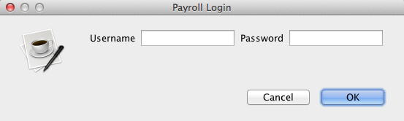

## Login Errors

In the event that a user incorrectly enters wrong login details, an error message will be displayed. The error is tailored to whichever text field was invalid, prompting the user to rethink their input.

### Incorrect Username

The following screen is displayed if the username does not match those stored in the database.

**(SCREENSHOT)**

### Incorrect Password

The following screen is displayed if the users password does not match those found in the database or associated with the username entered.

**(SCREENSHOT)**

### No details Entered

If the user leaves both the username and password fields empty, the following message is displayed to the user.

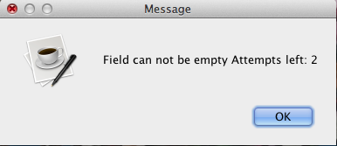

# Customer Details

After the system accepts the username and password, the user is presented with the Employee Details screen. This is the first page the user sees of the application; from here the user can navigate through the application using the tabbed screens.

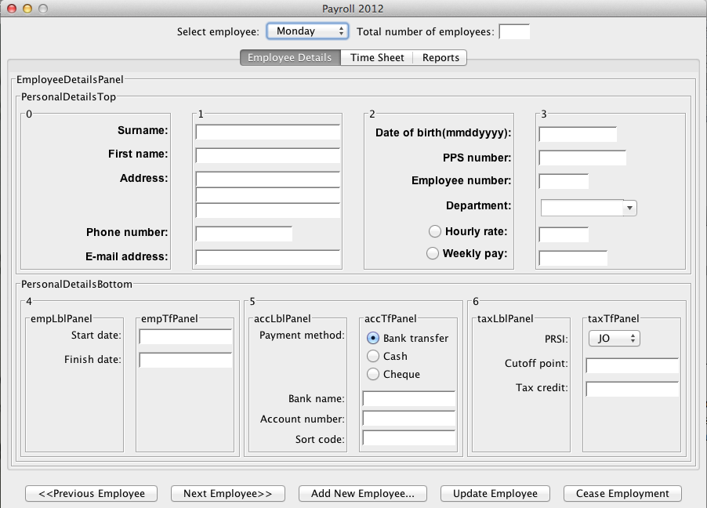

From the employee details screen one can add a new employee, update a current employee or cease their employment. The main function of this page is to provide access to employee details or to update/create employees. An individual employee can be selected from a combo box at the top of the screen.

Details available for display or submition on this screen are as follows:

|  |  |
| --- | --- |
| Surname | Employees Surname(s) |
| First name | Employees First Name(s). |
| Address | Employees current place of residence |
| Phone Number | Contact telephone number for the Employee |
| E-mail | Employees E-mail address |
| Date of Birth | Employees Date of Birth |
| PPSN | Employees Personal Public Service Number |
| Employee ID | Unique ID number assigned by the system to each employee |
| Department | Department to which the employee is assigned |
| Hourly rate/Weekly rate | Employee can either be paid per hour or receive an annual salary. Only one may be selected |
| Employment start date | Date employee started employment |
| Employment end date (if applicable) | Date employee ceased employment |
| Payment method | Method by which wages are paid to the employee, only one selectable |
| Bank name | Name of employees bank. |
| Account Number | Account number of the employees current account |
| Sort code | Sort code for the customers branch |
| PRSI | Employees Pay Related Social Insurance contribution. |
| Tax cutoff point | Employees annual tax cutoff point. |
| Tax Credits | Employees annual tax credits. |

# Adding Employee’s

To create an employee and add their details to the database, details should be entered into the fields provided. The following fields are mandatory and must contain a valid value to create a new employee:

* Surname
* First Name
* Address
* Date of Birth
* (ETC)

Clicking ‘Add New Employee..” will create a new row with the specified details in the database. Timesheets and Reports can now be created for the employee. This row is a permanent addition, and when the employee’s employment ceases, any irrelevant details are cascaded to null.

**(SCREENSHOT)**

# Updating Employee Details

Updating an employees details is carried out in a similar way to the procedure for creating a new employee. However, first the employee to be updated must be selected from the ‘Select Employee’ combo box at the top of the page. Once selected, the displayed employee details can be edited and updated to the most recent available information.

**(SCREENSHOT)**

# Updating Employee Revenue Details

This section shall provide a detailed description of the update employee revenue details procedure.

# Timesheets

This section shall provide a detailed description for entering timesheet details for each employee.

# Payslips

This section shall provide a detailed description printing employee payslips.

# Payroll Report

This section shall provide a detailed description for printing the weekly payroll report.

# Revenue Reports

This section shall provide a detailed description for printing the revenue reports as listed below.

## Form P30

A P30 is a bi-monthly Pay As You Earn (PAYE) and Pay Related Social Insurance (PRSI) return to the Revenue. In this form the employer declares the total amount of PAYE and PRSI deducted from his employees wages. This form is sent to the revenue along with a cheque for the liability.

## Form P35

A P35 must be submitted by each registered employer by the 15th February for the previous year ending 31st December.

## Form P60

## Form P45

# Glossary

An online version of this document shall be developed in HTML and posted online.